**CMA US Landing Page**

Offered by the Institute of Management Accountants, USA, Certified Management Accountant, is the most valued management accounting program globally for entrepreneurs, experienced professionals and graduates with or without a commerce study background.

This certification has been the global benchmark for management accountants and financial professionals CMA helps you to be “future-proof” as you will increasingly be expected to provide “insight” and “foresight”

1. **CMA Advantages**

* Global credibility as a F&A professional
* In-depth knowledge about Management Accounting, Finance, Business Economics and Management concepts required for a business professional
* Industry-relevant skills
* High demand equals higher salaries
* Assured jobs & career progression in India & USA
* **Higher earnings:** As per the recent survey, CMA professionals earn 60% more than the peers with no professional qualification.
* **Flexibility:** The course consists of only 2 parts which can be completed within 6-8 months. Hence, making it ideal for those who want to speed up their career in a short time.
* **Career prospect:** CMA professionals are highly preferred in public or corporate accounting, and can fill positions as analysts, planners, auditors, managers, and accountants.

1. **CMA Course Duration**

Depending on the aspirant’s plan and study schedule, the US CMA certificate can be completed in a minimum of 6 months to 3 years. As per the guidelines of IMA, an aspirant must complete the exams within 3 years from the date of registration.

1. **CMA US Testing Windows**

IMA conducts US CMA exams in three testing windows every year in India and all over the world. The testing windows are as below.

January – February

May – June

September – October

1. **CMA Exam Pattern and Passing Score (you can create this in diff format)**

US CMA examination pattern consists of Multiple-Choice Questions (MCQs) as well as Essay type questions. Part 1 and Part 2 are four–hour tests containing about 100 MCQs and 2 essay questions. Aspirants will be granted 3 hours to finish the MCQs and 1 hour to complete the Essay type questions.

75% of the Examination consists of MCQs (Multiple Choice Questions)

25% of the Examination consists of Essay Questions

US CMA exams are graded for 500 points, and an aspirant must score a minimum of 360 to qualify for the exams. Both parts follow the same pattern.

1. **Syllabus – Take from our brochure**

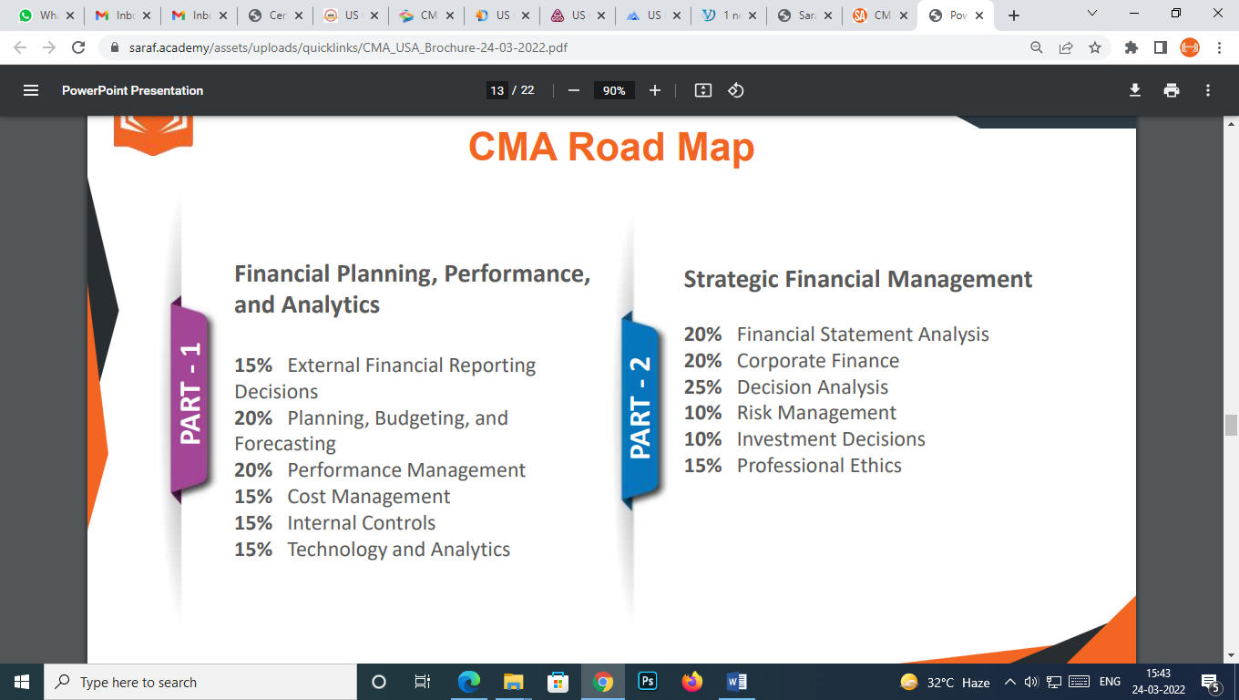

1. **To Earn CMA US**

* Bachelor's degree or professional accounting certification required
* 2 years of work experience required
* Successful completion of Parts 1 and 2 of the exam

1. **What we will provide - Give it in Icon form**

* 150-200 hours per part of Training Classes - LIVE and Recorded
* Get Trained by Industry experts
* Study Resources – In-house Notes & Presentations
* Mock Tests

1. **Why Us – same**
2. **Top Companies hiring our students**
3. **Testimonials –**
4. **Raghavan Nagaraj –**

I am Mr. Raghavan Nagaraj, Finance Manager - REZAYAT COMPANY LIMITED, AL KHOBAR. It is with great pleasure I wish to inform that I have scored 450/500 - 90% marks in CMA part 1 exams conducted in October. The whole credit goes to Saraf Academy and especially to Prakash Sir. He breaks down complex concepts in such a way that even an average student like me could get such high marks. I also want to appreciate the tech team, they really supported to resolve issues asap, in fact on one occasion they even supported me during 12 midnight India time and again came back early morning to confirm the problem is resolved. Thank you so much Saraf Academy and team for the excellent service...

1. **Rakshit D.R**

I am Rakshit D.R. currently pursuing CMA USA, I didn't think I can do it alone. I was very afraid but then I decided to take the classes from Saraf Academy and Prakash sir helped me a lot through my journey to crack CMA USA PART-2. All thanks to sir for helping me out, clearing my doubts and personally messaging you has been helped me a lot.

1. **Mohammad Ali**

Hi! I am Mohammad Ali It has been a great learning experience with Saraf Academy . Excellent in depth coaching and strategy to study and pass has been provided by Prakash Saraf sir. Easy access to Prakash sir over emails and Whatsapp has given much flexibility in clearing doubts in CMA. I would highly recommend all students who aspire to become CMA to get coaching from Prakash Saraf

1. **Devender Kalra**

Hi! I am Devender Kalra I have become Qualified CMA- US. The learning experience with the Saraf Academy is too Good. I am very thankful to our Prakash Saraf Sir who helps me a lot. He is always there for the help whenever I find difficulty anywhere he helps me as well as the IT team also helps me while facing issue in running classes, installing software etc. Sir's team always helpful.

1. **FAQs**
2. **What are the requirements to become a US CMA?**

**Ans** - In order to take the US CMA exam, you must have a university degree. To qualify for US CMA eligibility, applicants must hold a bachelor's degree from any stream (except humanities) or a professional accounting certification with at least two years of related experience. Institute of Management Accountants (IMA) has flexed the US CMA exam entry criteria for undergraduates who can have another seven years to produce the documents upon successful completion of two parts of the exam.

To summarize, for US CMA, you'll need to meet the following requirements:

Membership in IMA®.

* Bachelor’s degree from an accredited college or university or an equivalent degree.
* Two years of professional experience in accounting or finance.
* Entrance into the CMA program.
* Completion of Part 1 and Part 2 of the CMA exam.

1. **Is it good to do CMA USA?**

**Ans** - Yes, if you want to make a career in the field of management accounting, internal control, risk management, financial statement analysis, planning, budgeting & forecasting, which can be completed within a very short period of time, say 1 year, then pursuing **CMA USA**will be the right decision for you.  
In the wake of globalization, most of the top MNC’s like **KPMG, Deloitte, PWC, EY, Microsoft, IBM, Nestle, Procter & Gamble, Wipro, Tata Consultancy Services, Accenture, IBM, Microsoft**prefer candidates with a global qualification like **CMA USA.**So, if you want to give your career, an international edge, you should definitely opt for **CMA USA.**

1. **Is CMA US Valid in India?**

**Ans** - There are lot of US companies operating in India, for example- Accenture, Capgemini, Cognizant, World bank, D.E.Shaw, Genpact- majority of them hire US CMA for FP&A profile- Financial planning and analysis, US CMA enjoys global recognition, thus there is ever increasing demand for US Certified management accountants in India.

1. **What are the employment opportunities for a qualified CMA USA?**

**Ans** - CMA professionals are finance professionals who can work as Accounts Manager, Cost Accountant, Financial Engineer, Lead Compliance and Forensics Specialist, Business Analyst, Manager Financial Reporting, Manager Accounts, Manager Costing, DGM Tax, Data Scientist, Risk Manager, Management Accountant, Senior Associate (Financial Effectiveness).

1. **How can one register for the CMA Exam parts?**

**Ans** - With three testing windows every year you can sit for the exam at any time or place that is feasible for you. The CMA exam is basically a computer-based exam and is administered at hundreds of Prometric testing centres all over the world.

* Testing windows are offered in January/February, May/June, and September/October. You have to pick your window.
* You then have to register for the exam on the IMA website
* You will receive your Authorization number along with further instructions.
* Schedule your exam appointment with Prometric

1. **What is the CMA Exam Retake Policy?**

**Ans** - Any part of the US CMA exam can be taken once in a testing window and retakes need a new registration along with fee payments.